GHANA ASSOCIATION OF THE BLIND
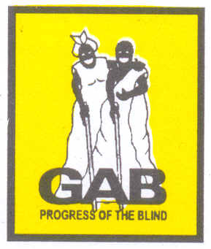

MANUAL FOR THE
COMMUNITY-BASED REHABILITATION PROJECT

2006

TABLE OF CONTENTS

# | TITLE | PAGE
 | Introduction | 4
Module 1.0 | Community Sensitization | 7
Step 1.1 | Seeking the involvement of the local authority to initiate a Community-Based Programme for BPS persons in the local area. | 7
Step 1.2 | Conduct a Baseline Survey in the local area | 9
Module 2.0 | Eye Screening And Functional Needs Assessment | 13
Step 2.1 | Eye Screening | 13
Step 2.2 | General and Functional Needs Assessment | 16
Module 3.0 | Functional Training For Bps Persons | 21
Step 3.1 | Orientation and Mobility | 21
Step3.2 | Daily Living Skills | 23
Step 3.3 | Employable Skills Training And Income Generating Activities For Adult Bps Persons | 27
Module 4.0 | Community Awareness And Capacity Building | 30
Step 4.1 | Awareness And Capacity Building Workshops | 30
Step 4.2 | Advocacy Workshops | 32
Module 5.0 | Weaning Off | 34
Step 5.1 | Weaning Off Period | 34
Step 5.2 | Internal and External Evaluation | 36
 | APPENDICES

LIST OF ABBREVIATIONS

BPS Blind and Partially Sighted

CBOs Community-Based Organizations

CBR Community-Based Rehabilitation
DA District Assembly
DAB Danish Association of the Blind

DPOs Disabled Persons Organizations

GAB Ghana Association of the Blind

ILO International Labour Organization

KAPS Knowledge, Attitudes, Practice and Skills

MCBR Mobile Community-Based Rehabilitation

NGO Non Governmental Organizations

O&M Orientation and Mobility

PWDs Persons with Disability

UNESCO United Nations Educational, Scientific and Cultural Organization

WHO World Health Organization

NTRODUCTION

This manual is born out of experiences gathered over ten years of implementing Community-Based Rehabilitation (CBR) for members, by the Ghana Association of the Blind (GAB). Established in 1963, GAB is the mouthpiece of the blind and partially sighted persons (BPS) in Ghana and has consistently advocated for their rights to be recognized in society.

In addition, GAB engages directly in the provision of services to improve the living condition of its members. One of such services is its CBR project supported by the Danish Association of the Blind (DAB). The CBR project was piloted in the Suhum-Kraboa-Coaltar District of the Eastern Region of Ghana for five years and was scaled up in a Mobile Community-Based Rehabilitation (MCBR) project which in the past five years has been implemented in eight districts.

An Evaluation of the project, conducted in November 2007, showed very successful outcomes. Targeted outreach numbers had been exceeded by over 25 percent. Beneficiary BPS persons, their families and community members testified to a marked improvement in the living conditions of the BPS, especially that the majority of the beneficiaries had been empowered to be independent and self sufficient through the services (counseling, training and financial assistance) provided.

So far, only three out the ten regions of Ghana have been touched cursorily by the project and expanding into other districts is urgently needed. However, that would require the input and participation of many more organizations and public institutions. Documenting experience and best practice in a manual such as this one is intended to provide a handy tool and skill enhancement to other organizations who want to participate in improving the condition of life for the blind and partially sighted persons by implementing a CBR project both in Ghana and elsewhere.

The definition of CBR
Community Based Rehabilitation (CBR) is a response to the need for adequate and appropriate services to be made available to a great majority of the disabled population. It is a strategy for enhancing the quality of life of the disabled.
CBR may be defined, according to three United Nations Agencies, ILO, UNESCO, and WHO, as a “strategy within community development for the rehabilitation, equalization of opportunities and social in\tergration of all people with disabilities. CBR is implemented through the combined efforts of disabled people themselves, their families and communities and the appropriate health, educational and social services” (WHO, 1994)

The purpose of this Manual
There is much that can be done to help someone who is a BPS person. With appropriate training, support and encouragement, an individual BPS can achieve a maximum level of functioning and independence, and further contribute to social development. This manual contains activities and strategies on how one can plan and carry out a Community Based Rehabilitation Programme that will promote independence in all daily activities for BPS persons. It describes activities for building the capacity of communities to sustain activities for BPS persons. The Manual stresses on gender and generational needs of BPS persons.

Who is this Manual for?

The Manual has been prepared for non-governmental organizations (NGOs), community-based organizations (CBOs) and public institutions that are providing or intend to provide rehabilitation service or support to BPS persons, both as implementers and as supervisors or evaluators of such programmes. It can be a useful tool to monitor the progress of work in the communities and to provide training in capacity competencies for service providers.

How is the Manual Organized?

This Manual has been organized in a step-wise manner: first, into main modules and further into steps. For example Module One (1.0) deals with Community Entry and Sensitization that is further arranged in steps of 1.1 Seeking the involvement of the Local Authority, and 1.2 Conducting a Baseline Survey. Indicators for monitoring the progress and performance have also been provided at the end of each module. The Executive of the local association of the blind and the Project staff will use the indicators as a guide for monitoring. Illustrations for training in Orientation and Mobility have been included in the appendices to aid field staff and other community workers.

Adapting the Manual

The information contained in the manual can easily be translated into the language used by the local people and can also be used by other Community Based Organizations supporting the implementation of CBR and other community development initiatives in Ghana and outside Ghana. In so doing changes may be needed to the text and illustrations in the appendix to make it more suitable for the specific community or to reflect particular environments and terrain.

The GAB Community-Based Rehabilitation Project is implemented at the district level, drawing on the resources of the District Assembly, the District Branch of the Ghana Association of the Blind and other district based agencies. However, since different countries and communities may have different structures and use different terms, the manual uses generalized terms such as “local authority” and “local association of the blind” to facilitate adaptability.

MODULE 1.0

COMMUNITY ENTRY AND SENSITIZATION

A successful community-based rehabilitation depends largely on community ownership and the capacity of the community and the BPS persons to sustain activities initiated to improve the conditions of the BPS. Right from the inception of any CBR programme, the relevant local or community structures should actively participate in all decisions concerning the programme.

Step 1.1: Seeking the involvement of the local authority to initiate a Community-Based Programme for BPS persons in the local area.
Duration: 2-3 weeks

OBJECTIVES:
- To negotiate with the Local Authority to set up a Community-Based rehabilitation Programme for BPS persons.
- To negotiate with the Local Authority to provide BPS persons with the same opportunities as other persons in the local area.

ACTIVITIES:
The following activities, which should take about 2-3 weeks,
are recommended as crucial in the community entry practices.

  - The Project Staff should request and arrange for a one-day meeting with the Executive Committee members of the local association of the blind, the local authority, and the Heads of the relevant departments of health, education, agriculture, social welfare etc.

  - At the meeting, the Project staff should clearly state what the organisation intends to do as a compliment to what the local authority and other agencies are already doing for BPS persons and other persons with disabilities (PWDs).

  - The Project staff should highlight the contributions the local association of the blind will make towards the development of the CBR in the local area. Benefits and responsibilities that individual BPS persons, their families and their respective communities will derive from the programme should also be clearly explained at the meeting.

  - Inform the meeting about how the local association of the blind will work in the local area to achieve its goals and objectives.

  - The specific roles of the local authority and its decentralized agencies of health, education, social welfare, etc. in the CBR should be discussed.

  - Any successful CBR implementation will largely depend on the following factors:
- Existence of an active local association of the blind in the area
- The local Authority’s readiness to participate and own the project.
- Accessibility of the relevant government departments and agencies
- Preparedness of the communities to participate and own the project

Step 1.2 Conduct a Baseline Survey in the local area (see Appendix 1 for an Interview Guide and Guidelines for the Baseline Survey)
Duration (8-12 weeks)

A baseline survey will provide reliable information on BPS persons in the local area. It is also meant to identify available services and the capacities of organizations and agencies in service provision to the population in the local area. Other issues to be addressed by the survey will be to determine current levels of the communities’ knowledge, attitudes, practices and skills (KAPS) in managing needs of BPS persons. The results of the survey will be used as benchmark indicators for developing capacity building plan, monitoring and evaluation of the project.

OBJECTIVES:
- To develop data and information on number of BPS persons and their current living conditions and on available resources needed for the development of the CBR project in the local area.

- To collect and analyze data and information on the level of knowledge, skills, behavior and practices towards BPS persons in the local area.

- To sensitize the community through the dissemination of the result from the baseline survey.

ACTIVITIES:
- The project staff will identify and train enumerators in the use of prepared interview guides and formats for data collection. Qualified volunteers of the community and existing Community-based organizations within the local area are recommended to be selected as enumerator in their respective operational areas.

- The project staff and some selected members of the local association of the blind will monitor the data collection exercise, and analyze the data and information returned with the involvement of the executives of the local association of the blind.

- The survey should also cover households. It will probably not be possible to get information from every household in the local area or the community. However, it should be possible to interview a sample of households.

- The data collected; for instance on number of BPS in the sample population will be extrapolated on the local area population to determine estimates of BPS persons in the local area.

(See appendix 1 for a sample of household and community guide for the baseline survey).

- Organize a one day seminar at the local area to disseminate results of the baseline survey to relevant stakeholders that will include a cross section of the population i.e. BPS persons, Local Authority members, Parents/Care Givers etc.

- Various action points needing intervention should be provided at the seminar.

- Results from the local area baseline survey indicating weaknesses in knowledge, attitudes, skills and practices about BPS persons in the local area should be used to design periodic capacity building workshops for the target population identified, e.g. BPS persons, schools, other service providers, parents/care givers, opinion leaders etc.

- The plan for the workshops should be discussed with the Local Authority for their inputs either in cash or kind e.g. venue for the workshops.

A consultant should be engaged to organise a two-day section on conducting Baseline survey for the project staff and volunteers.

INDICATORS

Community Entry
- Number of Local Authority Members informed about the introduction of the CBR in the local area

- Number of members of local association of the blind participating in the discussions with the Local Authority disaggregated by sex.

- Commitment made by the Local Authority to implement the CBR either by cash or in kind.

- Number of service providers in the local area informed about the implementation of the CBR in the local area.

- Commitment made by service providers to the implementation of the CBR in the local area either by cash or in kind.

Baseline Survey

Household data
- Number of community members participating in data collection and analysis.

- Total number of BPS persons identified as a percentage of total number of persons covered in the survey.

- Total number of BPS persons identified by the survey disaggregated by age and sex.

Community Data and Information
- Nature and type of services being provided to the population in the local area that can benefit BPS persons e.g., early childhood centers, schools, skills training centers, health facilities etc.

- Level of capacity of the agencies and institutions available in the local area in terms of personnel, skills and resources relevant to the needs of BPS persons.

- Nature and type of CBOs and NGOs operating in the local area.

- Level of knowledge, attitudes, practice and skills of family and community members relevant to the needs of BPS persons in the local area.

MODULE 2.0

EYE SCREENING AND FUNCTIONAL NEEDS ASSESSMENT

Step 2.1 Eye Screening
Duration: (6 weeks)

The Eye Screening Exercise is meant to assess the sensory functions relating to sensing the presence of light and sensing the form, size, shape and color of the visual stimuli. It is meant to ascertain the degree of blindness and provide an assessment of the medical interventions required by individual BPS persons in the local area.

OBJECTIVES:
- To assess and ascertain the various visual function, diseases and blindness of individual BPS persons in the local area.

- To develop a referral and treatment plan for BPS persons in the local areas following from the screening.

ACTIVITIES:
- The exercise will require the active collaboration of the local health facility, local authority and the Local association of the blind.

- The Project staff will contact the Local authority to request for support for the exercise.

- The Project staff and the Local area health personnel will agree on the following and develop a work plan for the Eye Screening Exercise.

  - Availability and number of Ophthalmic Staff required for the screening.

  - List of logistics required and the operational cost of the screening.

  - Itinerary for the exercise should be developed and agreed on. The itinerary should consider the unigue characteristics and the needs of the communities (e.g. farming/fishing and market days of the communities) and the clinic days of the ophthalmic staff.

  - Means of communicating the itinerary to the communities and responsibilities of the local authority.

- The Project staff will then discuss the agreed work plan and the operational details (including the itinerary for the exercise) with the head of local authority and agree on the specific support from the project, and the contributions to be made by the Local Authority.

- The local authority will undertake information dissemination on the screening exercise in all the communities in the local area, and seek the active participation of the Local authority members to mobilize parents/care givers and BPS persons for the screening exercise. The project shall be responsible for the logistics required for the exercise.

- On the day of the screening and before individuals are screened, it is recommended that the ophthalmic personnel and the project staff take turns to brief the gathering on the following issues:

  - Common eye diseases identified in the local area.

  - How these diseases and conditions could be prevented.

  - The objectives of the CBR project need to be highlighted to include support for those whose condition cannot be reversed, and

  - The support required from the community members towards all BPS persons.

- At the end of the screening exercise, the ophthalmic personnel will produce a report indicating the number of BPS persons whose sight could be reversed either through surgery or drugs and where referral support could be obtained.

- The report will then be made available to the project staff. The project will work out the details of the referral support with the individual BPS persons/parents/care givers, and the local health facility. The project staff will prepare the plan of the referral support for each individual BPS person, which will cover the following:

  - Where the referral service will be available e.g. Name of Hospital.

  - When the service will be available i.e. date and time of the service.
  - What resources will be required e.g. fund for the service?

  - Who will provide the resources and when the resources will be available?

Step 2.2 General and Functional Needs Assessment
Duration: (12 weeks)

Systematic and purposeful assessment of needs of BPS persons should be the starting point of any successful rehabilitation plan or training for BPS persons. An Assessment of BPS person is done to understand the individual and his or her relationship with the immediate environment. Most rehabilitation experts (expatriates and locals alike) do not take the trouble to visit the homes and communities where BPS persons live when assessing needs and evaluating the likelihood of the success of proposed intervention.

Needs assessment is the process that determines the present and specific needs and skill level of the individual BPS person. It is a basic tool for planning what needs to be done to maintain, improve or bring about changes in the individual BPS person’s environment or both.

BPS persons whose conditions cannot be reversed or improved by medical intervention (either through surgery or drugs) will need to be assessed and suitable interventions designed to deal with the problem.

Assessing needs of BPS persons must involve the individual BPS person, the family and all significant others in the community. The objective of this participatory approach is to encourage the others to support the individual BPS person in his training and/or rehabilitation.

There should be sufficient preparation by the field worker and the individual whose needs are to be assessed.

OBJECTIVES:
- To determine present functional capacity needs of individual BPS persons in the community to include early childhood and gender needs.

- To design an intervention plan for the individual BPS person.

The objectives of the assessment should clearly be explained to the individual BPS person. Care should be taken not to set unrealistic targets. Where necessary, counseling should be provided before undertaking the assessment.

The assessment should address both gender (sex) and generational (age) needs of the individual.

AGE GROUP | GENERAL AND FUNCTIONAL NEEDS
0-6 YRS | Birth Registration  Breast Feeding  Early Childhood Development  Training (incl. Play)
7-15 YRS | Parental Guidance  Mobility and Daily living skills  Placement in basic school  Carrier Guidance and Counseling  Braille Literacy Skill
16-25 YRS | Placement in post basic school  Employable Skill Training  General Mobility and Daily Living Skill  Empowerment (Social and Communication Skills)  Braille literacy skills  Reproduction Health Skills (incl. HIV/AIDS)
26-59 YRS | Entrepreneurial and Business Management Skills  Job Placement  Financial Management Skills  Braille Literacy Skills  Empowerment (Social and Communication Skills)  Mobility and Daily Living Skills
60> | Appropriate Mobility Skill relevant to age and physical fitness  Family and group support  Leisure and recreation  Counseling on the management of problems associated with ageing

- The Field staff will book appointment with individual BPS persons and diligently explain the purpose and outcome of the screening exercise.

- The Field staff will visit the BPS person on the appointed day and time.

- The Field staff interviews BPS persons on his/her capabilities, potentials and shortcomings using prescribed assessment format in appendix (2).

- The Field staff supports the individual BPS person to set goals based on the identified needs and determine priority areas for intervention.

- Both parties identify respective roles and produce a work plan.

- Suitable time and duration for planned intervention activities are agreed on.

- The field staff identifies and discusses with other relevant stakeholders (including family members) whose support, inputs and expertise would be needed for the required intervention.

- The field staff will prepare a final intervention plan agreed upon with the BPS person, the family and or caregiver.

- The field staff will prepare and maintain record on each contact with the BPS person, the family and or caregiver.

INDICATORS

Eye Screening
- Total number of persons screened as a percentage of the population of the local area.

- Total number of persons screened as a percentage of the estimated.

- Number of BPS persons identified during the baseline survey.

- Total number of persons screened disaggregated by age and sex.

- Total number of persons identified for treatment and referral.

- Number identified as incurable BPS.

Functional Needs Assessment
- Total number of persons assessed as a percentage of the estimated number of BPS persons identified during the baseline survey.

- Total number assessed disaggregated by age and sex.

- Breakdown of number of BPS persons assessed and needs identified.
MODULE 3.0

FUNCTIONAL TRAINING FOR BPS PERSONS

The aim of any rehabilitation process is for the individual to achieve a maximum functional independence level. This does not mean that every BPS person must learn to do everything by him or herself. The person must be given the chance of returning to normal community life, doing as much as possible without assistance, despite some residual limitations. The aim of CBR is to support identified BPS persons in the communities to achieve a maximum functional level with his or her motivation, interest and abilities.

Step 3.1 ORIENTATION AND MOBILITY

“Orientation” is the process of acquiring a mental picture of one’s environment. That is, knowing the relationship of objects in the environment, and the relationship of one’s body position to the objects. Simply, it is the ability to locate oneself in one’ environment.

“Mobility” is movement, or the ability to move in the environment from one place to another. It describes all the situations ranging from moving around within a single room in a house through traveling from one town to another or even between countries. To be mobile, the blind person must be able to gather and use sufficient environmental information in order to avoid hazards and to maintain efficient progress towards the desired destination.

The training that teaches the BPS person to move about safely and efficiently is called “Orientation and Mobility”. These two (2) long words are sometimes shortened as ‘O&M’.

Based on the assessed needs and the priorities agreed upon, the field worker would begin actual transfer of skills to the individual BPS person, a family member and or a caregiver. This is done theoretically through discussion and a practical demonstration of the skill until the BPS person becomes perfect. Major areas of consideration include the following activities:

ACTIVITIES:
- The field worker will provide training in the following areas to the BPS person, a family member or a caregiver:

  - Sensory training (indoor and outdoor)

  - Room familiarization.

  - Use of landmarks and clues.

  - Introduction to the use of white cane and long cane techniques.

  - Route travel with white cane.

  - Sighted guide techniques appropriate at various location (market, farm, school etc.)

  - Independent travel techniques.

  - Protective methods

Step 3.2 DAILY LIVING SKILLS

Daily living skills include all those activities that people do every day. Examples are: getting dressed, bathing, using the toilet, washing clothes, shopping, cooking eating, cleaning the house etc. the nature of the services would depend on the age of the individual, gender, period of onset and degree of visual impairment, the level of previous training and potential of the individual

OBJECTIVES:
To enable individual BPS persons achieve maximum functional level of independence.

ACTIVITIES:
- The field worker will provide training in the following areas to the BPS person, a family member or a caregiver:

- General cleaning, washing and ironing

- Care and storage of cloths

- Personal grooming

- Shaving

- Social skills

- Communication skills

Age and Gender needs in daily living skills

Pre-school Age Group (0-5 years)

In the case of the BPS child below the age 5 years, it is necessary to impact training in mobility, self-care and other aspects of rehabilitation to parents who in turn would impact training to the child.

- The field worker would be required to provide the following services:
- Organize medical check up of the child.

- Confirm the impairment of the child.

- Train the parents in orientation and mobility, activities of daily living and self-care.

- Counsel the parents as regard acceptance of the child and related aspects.

- Create public awareness about the importance of inclusive education, child preparatory services etc.

- Provide appropriate early learning kit to the child for helping in sensory training, tactile discrimination, and orientation about shape and textures.
School Age Group (6-15 years)

- The field worker will provide training in the following daily living activities in this age group:

- Toilet training, body cleanliness, dental care, brushing of teeth, keeping toiletries at proper place. Adolescent girls should also be trained in menstrual hygiene.

- Shaving, putting on clothes, wearing footwear, oiling and combing of hair, cutting nails, cleaning of ear, personal grooming etc.

- Drinking from a cup, eating without spilling, use of spoon, holding a plate etc.

- General cooking techniques: lighting of stove/coal pot, boiling of water, cooking etc.

- Washing and cutting vegetables, preservation and storage of food etc.

- Cleaning utensils, keeping them properly, sweeping the house, adjusting household goods, mopping the floor, washing clothes etc.

- Making and folding beddings.

- Training in social etiquette including posture and social decorum.
- Use of currency: counting currency, identification of coins and notes, keeping money carefully, and simple accounting.

- Memorizing names of family members, neighbors, peers and own village etc.

- Threading a needle, simple mending, stitching buttons, hooks buttonholes etc.
* a seminar for parents of visually impaired children between ages 0-15 in the project area can be very helpful both as a resource system and an advocacy group for the welfare of the children*

Working Age Group (16-65 years)

In addition to the skills provided to age group 6-15 years, the following components should be provided to this year group (16-65years):

- Elementary darning and mending of clothes.

- Going to farm or work place independently.

- Pounding and grinding of grain and spices.

- Performing social obligation to family and community.

- Taking care of children and elderly in the house.

- Health-care of children etc.

- Recreational activities.

Step 3.3 EMPLOYABLE SKILLS TRAINING AND INCOME GENERATING ACTIVITIES FOR ADULT BPS PERSONS.

The field worker before assisting individual BPS persons to undertake employable skills training will undertake a brief social, vocational and educational assessment of each BPS person to get an indication of what work they are interested in and are able to do. It will also give an idea on what training and employment would be suited to an individual’s capabilities and interest.

The objective of undertaking an assessment is to look into the person’s capability and interest for work and training:
- What type of work he/she would like to start?

- What knowledge and skills are required for the work?

- What kind of training will he/she need?

- Where and how will he/she sell her products?

- Where will he/she think money could be found for the work or business?

- Besides getting income, what will he/she personally gain from the work?

The following areas of training (but not limited to) in Agriculture and other vocational skills are recommended:

Agricultural skills:
- Seed identification

- Land clearing

- Planting/harvesting and storage

- Marketing

- Record keeping

- Business Management (including saving)

Similar training in animal husbandry could be provided but will require different processes.

Vocational skills:
- Soap/powder and pomade making

- Oil extraction

- Food processing

- Trading

Support under a Revolving Loan Scheme
The field worker will support individual BPS persons needing start up capital to access the revolving loan scheme to be provided by the project. The project staff will also have to establish and assess linkages with other mainstream credit schemes that BPS persons can benefit from.

Referral Support
The field worker will prepare list of all individual BPS persons needing specialized services including early childhood development, schooling, vocational skills acquisition etc. and refer them to the relevant department and agencies in the local area.

INDICATORS

- Total number of BPS persons with functional training and a breakdown of type and nature of training.

- Total number of persons covered with functional training disaggregated by age and sex.

- Performance level of BPS persons receiving functional training over a period of time (i.e. weekly, monthly or annually).

MODULE 4.0

COMMUNITY AWARENESS AND CAPACITY BUILDING

Community awareness and capacity building begins from the inception of the CBR programme and it is continued through the entire project period. The report on the baseline survey will provide additional information in the areas requiring consideration during the awareness and capacity building activities. The local association of the blind takes the responsibility and will be involved at all stages. The association additionally will be equipped with skills in advocacy, leadership and organizational competencies.

Step 4.1 AWARENESS AND CAPACITY BUILDING WORKSHOPS

ACTIVITIES

Coverage:
The Awareness and capacity building activities will be designed to cover though not limited to the following groups in the community
- Churches

- Schools

- Civic Group/local associations (including women and youth groups)

- Staff of relevant departments and agencies

- Opinion leaders (including Local authority)

- Parent of BPS babies and children
Processes of Awareness and Capacity Building:

The field staff will support the local association of the blind to organize seminars and workshops in the respective communities. The support will include the following:

- The field staff will target a specific group within the community.

- Arrange a meeting with the leadership to discuss the programme and agree on the issues to be discussed and their relevance.

- Identify a suitable day and time for the activity.

- The field staff will inform the leadership of the local association of the blind and any other resource person.

- The team will visit on the appointed time to undertake the Awareness and Capacity Building activity

Suggested Issue to be discussed:
- Common Eye diseases, causes and preventive measures in the community.

- History of services, social attitudes and perception on blindness.

- Impact of blindness on the family, community and the nation.

- The CBR project.

- The Role of the various actors involved in the CBR project.

- The Role and activities of the local association of the blind

- Consequences of not including the visually impaired in the National Development agenda

Step 4.2 ADVOCACY WORKSHOPS

Coverage:
The Advocacy Workshop and activities will cover the following groups of BPS persons within the local area.
- Executive member of the local area association.

- Leadership of the Women and Youth Wings of the local area association.

- Identifiable NGOs and CBOs.

Processes of Advocacy Workshop:
The field staff will support the local association of the blind to organize seminars and workshops in the respective communities. The support will include the following:

- The field staff will target a specific group of the local association of the blind

- Arrange a meeting with the leadership to discuss the programme and agree on the issues to be discussed and their relevance.

- Identify a suitable day and time for the activity.

- The field staff will inform the leadership of the local association and any other resource person.

- The team will visit on the appointed time to undertake the training on Advocacy.

Suggested Issues to be discussed
- Summary of national disability agenda (including existing policies and legislation)

- Definition and Explanation of Advocacy

- Stages of Advocacy Planning:

  - Identification of issues

  - Analyzing and setting objectives

  - Deciding on specific messages and audiences

  - Deciding on activities (campaigns, discussion etc)

  - Setting success indicators

MODULE 5.0

WEANING OFF

Step 5.1 WEANING OFF PERIOD

The weaning off period is the stage during the project implementation where training and/or services end or are reduced considerably. This stage is however preceded by a review or an evaluation of an individual BPS person’s needs before and after training or service provision.

The goal of training and service provision to BPS person is to develop a level of functional independence especially at home and in his community. CBR become a strategy to achieve this goal not only for individual BPS person but to develop and strengthen the capacity of the local authority to sustain the training and service provision to BPS persons and their families. The weaning off period will involve the following activities:

- An assessment of the situation of the BPS person before training or service provision (as carried out under Module 2 step 2.2)

- A review of the training plan

- A review of activities undertaken to improve the individual’s circumstance.

- Dexterity in the use of a particular technique learnt.

- Impact and sustainability of activities in the family and the community.

- Possible family/community and local area support with exit of the field staff.

The field worker will agree with the individual BPS, the family and the community on a plan for weaning off with time line. The plan will also include following up activities to ensure sustainability of the programme.

Exit Strategy
Plan and implement an exit programme which places responsibility on the local authority and community leaders to support the local association of the blind to sustain and expand project impact.

INDICATORS
- Total number of persons covered with awareness and skills relevant to needs of BPS persons in the local area.

- Nature and type of awareness programmes and skills relevant to the needs of BPS persons.

- Level of competencies developed among members of the local area branches of LOCAL ASSOCIATION OF THE BLIND in the area of advocacy, leadership and organizational skills, fundraising etc.

- Plan of action developed for advocacy, skills training and fund raising programmes at the local area level.

Step 5.2 INTERNAL AND EXTERNAL EVALUATION
There shall be a process and an end of project evaluation by the executives of local association of the blind, and the field staff to secure efficiency and effectiveness in project implementation. The evaluation should ensure a match between agreed inputs and outputs within the stipulated time frame. Results, benefits and impact on needs of BPS persons, their families and the community will also be established.

Appendix (1)

RELEVANT QUESTIONS TO BE CONSIDERED UNDER THE VARIOUS STEPS OF THE CBR STEPWISE PROCESS

STEP 1: FEASIBILITY STUDY

(Background Information)

1. Name of local area ………………………….. Location……………………

Name of local area capital ……………………

2. Demography

a) Population

Sex | Number | Percentage (%)
Male
Female
Total

b) Age Structure

School Going Age (5 – 18) | Number | Percentage (%)
Working Age (19 – 59)
Aged (60 and above)

c) Population of PWDs

Type | Number | Percentage (%)
Blind/Partially Sighted
Physically Disabled
Hearing Impaired
Mentally Disabled
Others
Total

Sex Ratio of BPS

Sex | Number | Total
Male
Female
Total

3. Political Structure

a. Number of Constituencies ………………………

Name of Constituency | Name of incumbent MP

Type of Council | Number
Urban
Zonal
Area

Population of Area

Name of Area | Population |  |  | Contact Person | Address/Tel. Number
 | Male | Female | Total

NGO/COLLABORATING AGENCIES

Name of Organisation (indicate whether NGO or others) | Objectives/Area of operation | Target group(s) | Requirements | Possible areas of collaboration

4. Major Economic Activities

Activity 1 |  | Activity 2 |  | Activity 3 |  | Activity 4 |  | Activity 5
Male | Female | Male | Female | Male | Female | Male | Female | Male | Female

a. Sources of raw material for the produce:

b Availability of good market for produce

i) Within the area

ii) Outside the area

5. Cultural Activities

Traditional Area | Name of Traditional Authority | Type of Authority | Cultural festivities | Period | Taboos and beliefs as they affect women, children, PWDs etc

STEP 2: SENSITIZATION OF LOCAL AUTHORITY/LOCAL AREA BRANCH

Local area Branch ……………………. Year inaugurated ……………………...........

a. Membership

Male | Female

b. Names/Positions of Executives

Name | Portfolio

c. Paid-up Members

Name | Address/Tel.Number
d Employment Status

Name | Type of Employment

e. Strength of Local area branch

Number of Meetings held per year  (cumulative)  2002…….  2003…….etc | Attendance |  | Other activities undertaken  (including collaboration with others) | Responsible person(s) | Impact
 | Male | Female

f. Office Situation

a) Location ………………………… Address ………………………………….

b) Occupancy (tick as appropriate)

i. Rented □ ii. Donated □ iii. Sharing with other(s) □

g. Special Comments …………………………………………………………….

…………………………………………………………….

……………………………………………………………

Local area Assembly

a. Attendance

Name | Department/Agency representing | Position held in department/agency | Contact address/Tel. number

b. Discussions

Issues discussed | Suggestions/Questions raised | Period of discussions | Decisions/Conclusions made | Assurances Received | Contact Person(s)

Special Comments ………………………………………………………………………...

………………………………………………………………………..

……………………………………………………………………….
6. Religion

Denomination | Estimated population | Estimated %

7. Other Useful Information

a. Any conflict situation (describe) ……………………………………………………….

……………………………………………………….

………………………………………………………

b. Literacy levels

Literate (%) |  | Non-Literate (%)
Male (%) | Female (%) | Male (%) | Female (%)

c. Health Status of the local area (indicate Doctor to Patient ratio) …………………………

d. Beliefs likely to inhibit or promote rehabilitation programme (describe)

…………………………………………………………………………………………

…………………………………………………………………………………………

e. Any perceived causes of blindness e. g. river blindness (describe) …………………..

…………………………………………………………………………………………

………………………………………………………………………………………..

STEP 3: ENUMERATION / ANALYSIS OF DATA

a. Personnel Used

Name | Status (tick)
 | Staff | Volunteer
Total
Percentage (%)

b. Sex ratio of staff

Sex | Number | Percentage (%)
Male
Female
Total

c. Period of Enumeration

Dates: From ………………… To ………………………………….

Number of Weeks ……………………………………………………

c. Operational Areas

Name of Enumerator | Zone | Expected Time of Completion | Actual Time Used | Reasons for Deviation

Special Comments …………………………………………………………………………

……………………………………………………………………………………………..

d. Means of Transportation used (tick as appropriate)

i Official vehicle yes □ no □

ii Motorbike yes □ no □

iii Public transport yes □ no □

iv On foot/walked yes □ no □

v Others (specify) …………………………………………………..

……………………………………………………………………

e. Coverage

Number of communities in zone ………………………………

Number covered… ……………………………………………

Number remaining …………………………………………….

Special Comments ………………………………………………………………

……………………………………………………………………………………

Resources needed for effective enumeration (list including quantity)

…………………………………………………………………………………….

…………………………………………………………………………………….

…………………………………………………………………………………….

f. Analyses of Data

i Gender distribution by zone

Zone | Male | Female | Percentage (%)
Total

ii Percentage Age Distribution

Range | Number | Percentage(%)
0 - 9
10 – 19 …
90 and above | Total

iii. Aged distribution (ie 60 years and above)

Range | Male | Female | Total
60 – 69
70 – 79
80 – 89
90 and above

iv Employment distribution

Type of Employment | Zone |  | Zone
Farming  Trading  Teaching etc | Male | Female | Male | Female

v. Plan used for enumeration …………………………………………………………

…………………………………………………………………………………………….

…………………………………………………………………………………………….

vi. Main lessons learnt …………………………………………………………………….

…………………………………………………………………………………………….

…………………………………………………………………………………………….

Step 4 EYE SCREENING

i Itinerary for Eye Screening

Date | Zone | Time | Medical/Other staff Involved

ii Attendance

 |  | Attendance |  |  | Remarks
Serial No. | Centre | Male | Female | Total

iii Prevailing conditions (per centre)

Condition (s) | Number affected | Percentage (%)
Cataract

Glaucoma etc

iv Attendance (general)

Name | Age | Sex | Town/Village | Condition | Remarks

v Referrals/Treatment

Type of Treatment/Referral | Number | Percentage (%)
Rehabilitation

Surgery

Drugs

Refraction

Others

vi Personnel Involved

Number of ophthalmologists ………………….

Number of ophthalmic assistants ………………

Number of opticians ……………………………

Number of GAB staff ………………………….

Number of other support staff …………………

Special comments ( e g availability of eye care centre, competence of staff etc)

……………………………………………………………………………………

……………………………………………………………………………………….

……………………………………………………………………………………….

vi Plan (eg how were people mobilized? What was the timing, number of publicity campaigns launched etc)

……………………………………………………………………………………………

…………………………………………………………………………………………….

…………………………………………………………………………………………….

Step 5 FUNCTIONAL ASSESSMENT/NEEDS IDENTIFICATION

 |  |  |  | Needs
Name | Age | Sex | Degree of Blindness | O &M | DLS | Education
(See details of Assessment form)

i Identify major problems of Assessment …………………………………………………

……………………………………………………………………………………………..

……………………………………………………………………………………………..

ii Compare male and female average time taken for skills and other training provided and make conclusions

Activity | Male Time | Female Time | Comments/Conclusion
O & M

DLS

Sighted Guide etc

iii Special comments ……………………………………………………………………….

………………………………………………………………………………………………

……………………………………………………………………………………………..

Step 6 COMMUNITY AWARENESS

Name of Community | Zone | Activity | Attendance |  | Topics discussed | Timing | Remarks
 |  |  | Male | Female

ii BPS Attendance

Name | Male | Female | Total

iii Opinion Leaders

Title | Name | Contact address/Tel No
Chief
Assembly member etc

iv Lessons learnt from interaction (e g any perceived change in attitude)

……………………………………………………………………………….

………………………………………………………………………………..

………………………………………………………………………………..

Step 7 WEANING-OFF PERIOD (see details of weaning-off process)

i Name …………………………………………………………………………..

ii Needs identified ……………………………………………………………….

iii Training (s) undergone …………………………………………………………..

……………………………………………………………………………………

…………………………………………………………………………………….

iv Duration of entire training ………………………………………………………

………………………………………………………………………………………

………………………………………………………………………………………

v Loan granted ………………………………………………………………………

vi Ability to use skills acquired: a) independently □ Good □ Average □ Poor

b) With support □ Good □ Average □ Poor

vii Best Practices (e g imparting of skills, performance of BPS before, during and after weaning)

………………………………………………………………………………………….

…………………………………………………………………………………………

…………………………………………………………………………………………

OTHERS

1. Revolving Loan

Name | Type of Project | Amount Granted | Interest Rate | Amount Due | Repayment Schedule

2. Special comments (e g progress made, impact assessment, saving habit etc)

………………………………………………………………………………………

………………………………………………………………………………………

……………………………………………………………………………………….

3. Local area Rehabilitation Committees (DRC)

Name of Rep | Organization Representing | Contact address/Tel. No | Meetings held/attended | Decisions made/follow-up | Person Responsible

4 Volunteers

Name | Local area/Period of Engagement | Work Schedule/Activities Undertaken | Observations/Recommendations

5. Parents of BPS Children

Name of Child | Address/Name/Location of Parent(s) | Meetings Held/Decisions Made | Person Responsible

6. Aged

Zone | Name/Location | Needs Identified | Support/Services Provided | Remarks

Special Comments …………………………………………………………………………

………………………………………………………………………………………………

………………………………………………………………………………………………

APPENDIX (2)

GUIDE FOR BASELINE SURVEY ON CBR

SECTION A: HOUSEHOLD PROFILE

- Number of people in household
  - Total number of people living in household
  - Number of men above 18 years
  - Number of women above 18 years
  - Number of persons below 18 years
- Number of BPS persons in household. Indicate Sex and Age of persons identified
(Carefully observe the people present in the household and ask the following questions).

Any member of the household who has difficulty or who cannot:
- See at all
- See well as the others
- See well when it is dark
- See objects that are far away, such as trees or birds
- See objects that are very close, such as seeds held in the hands.
- Who frequently has painful and red eyes?
- Who frequently has tears (watery) in the eyes?

SECTION B: COMMUNITY PROFILE

- Demographic information about respondents
  - Age
  - Religion
  - Marital Status
  - Occupation
  - Highest Level of Education
  - Location.

- Identify community members who can provide information about BPS in the community.
- Number of people in the community already trained to share information in the community about BPS persons.
- Number of awareness seminars on blindness attended by any member of the community.
- Number of disability related activities initiated in the community
- Sources of information about BPS persons.

- Identify community members who can promote positive attitudes and build community capacity to manage and support BPS related activities.
  - Number of people expressing willingness to support BPS persons to go to school, learn a vocation or engage in a business.
  - Number of households living and supporting BPS persons.
  - Number of activities initiated by the community to support BPS persons or other persons with disabilities.
  - Number of organizations (including NGOs, CBOs) working in the community. Indicate various areas of engagement.
  - Number of volunteers providing support in various areas in the community.
  - Existence of an association of or for BPS or other persons with disabilities.
- To stimulate and facilitate collective community support to BPS persons (including children and women)
  - Leaders of the community (chiefs/elders, assembly members, unit committee members, leaders of organized groups) expressing willingness to support activities for BPS persons.
  - Leaders already participating in activities for BPS persons in the community.
  - Number of BPS persons receiving support from other community members.
  - Number of people supporting BPS persons (as guides, through financial and other contributions)
- To identify, strengthen and promote the use of appropriate referral points available to the community.
  - Number of schools in the area.
  - Number of health care facilities serving the community.
  - Number of skills training facilities serving the community.
- To promote collaboration and networking with government departments, NGOs and other structures that in a way may facilitate community efforts.
  - Major sources of income for segregated groups e.g. women, men, ant the youth.
  - Other sources of income to community members.

APPENDIX (3)

CBR STAKEHOLDER PARTICIPATION ANALYSIS

INTEREST GROUP | CHARACTERISTICS | EXPECTATIONS | POTENTIAL STRNGTHS | POTENTIAL WEAKNESSES | IMPLICATIONS
BPS Persons | Limited functional skills  Inability to negotiate for improved services and opportunities | Improved living conditions.  Access to services and opportunities. | Ability to participate and take decisions | Inadequate information and skills  Restricted environment, negative social attitudes and systems | Mobilization  Training in functional skills Capacity Building
Family / Community | Fear, Stigma, Poverty | Willing to see improvement in living conditions of BPS person | Can provide resources to support BPS members | Limited information and skill relevant to support BPS members | Mobilization, Provision of information and skills  Access to district- based poverty reduction schemes
Relevant Service Providers in Education, Health Social Welfare Agric. | Access to information and skills. Limited financial and materials resources | Desire to patronise BPS persons which can influence negatively. | Can provide technical and financial resources to the BPS  Provide recognition and visibility to GAB | Needs of BPS persons not a priority.  Limited resources to influence inclusion of BPS person in mainstream activities. | Sensitization on the rights of BPS persons.  Adequate involvement to facilitate inclusion of BPS persons in annual work plans and budget for sustainability  Sensitization on the needs and rights of BPS persons.
Local Authority | Responsibility for all development issues in the district.  Controls resources in the district.  Access to poverty reduction funds | Wants to be involved in all development projects in the district | Adequate influence on development issues in the district, and can give recognition and visibility to the project.  Can be sensitive to the rights and needs of BPS persons. | If not involved adequately, the Assembly can influence the project negatively. | Negotiate on roles of both the Assembly and GAB and produce a Memorandum of Understanding (MOU)  Ensure inclusion of needs of BPS persons and their families in annual work plans and budgets
Local Association  of the Blind | A clearer vision and  mission to support  BPS persons and their  families | To gain greater  credibility in  achieving its mission | Recognition by the Government  Wider international net- work.  Visibility and credibility among BPS persons | Over reliance on Donor Support  Limited local resources | Need to provide the ff:  Facilitation  Sensitization  Mentoring  Empowerment  Leadership Role Models.

Appendix (4)

How to train the people to move around alone

When the person remembers things in the home and the yard, teach the person to walk in these areas without holding on to you. Help the person to protect him or herself when walking alone in the house and yard.

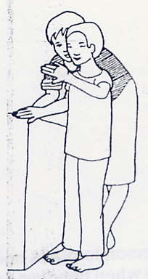 | Teach the person to walk in the house holding one arm up with the hand in front of the face. The hand should be held away from the face. The hand protects the person’s face and head. The person can use the other hand and the feet to fine things and to walk around them.

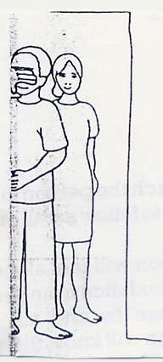 | Begin training the person to walk in the house without holding on to you. Keep talking while he or she is moving. Describe and explain what is around him or her. Repeat what you say until the person remember what is there when he or she moves around alone

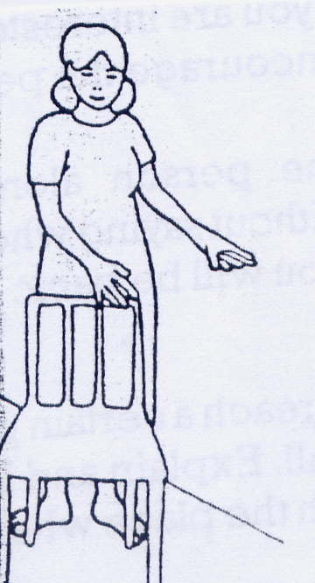 | When the person first stars walking without help, he or she may walk into doorways, walls, or furniture. Holding one hand in front of the face will protect the person

.

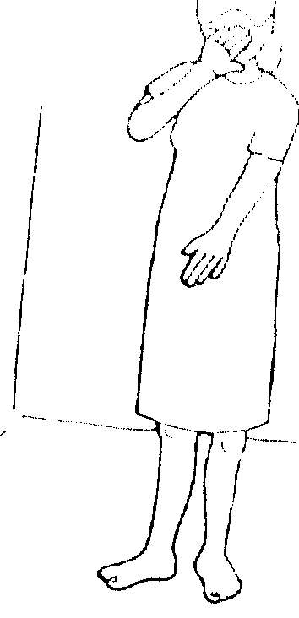 | You can also teach the person to walk inside the house holding one arm down across the body. This arm will protect the person and will also help him or her to find objects, such as chairs and tables.  The person may want to walk in the house with one hand in front of the face. The person may then use the other arm down the body

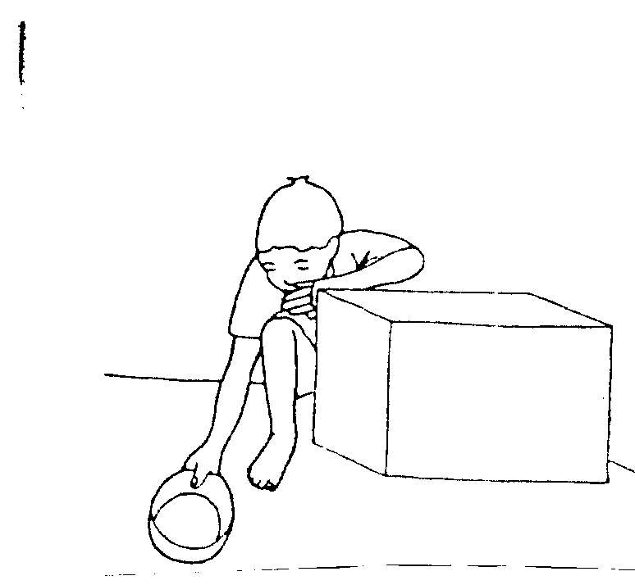 | Teach the person to place one hand in front of the face when bending down. This protects the face from hitting objects such as tables and chairs.

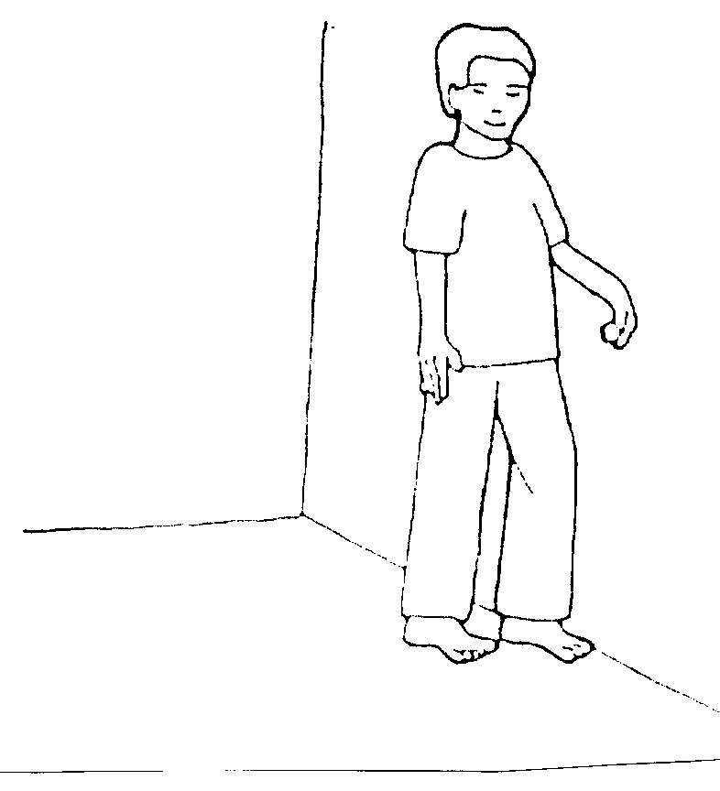 | You can also teach the person to use the back of one hand to follow a wall or a table.  At first the person will feel alone when walking without guidance from you. If this happens, stay close by and talk to the person. The person will know that you are closed by and that you are interested in him or her. This will encourage him/ her.  Never leave the person alone in an unknown place without saying where he or she is and when you will be back.

Help the person learn in which direction he or she should go to reach a certain place. To do this, start from a known place, for example, a doorway or a wall. Explain and help the person to remember when and how to change direction to reach the place where he or she wants to go.

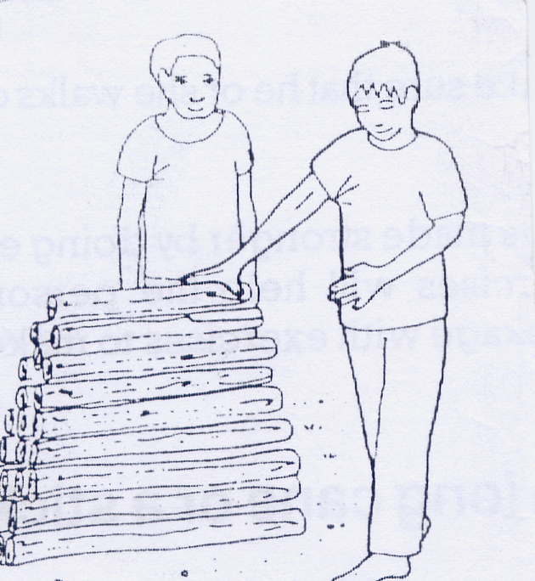 | When the person can walk alone in the house, teach him or her to walk alone in the yard.  The person can place one arm down across the body to protect him or herself. He or she can use the other arm and the feet to find objects in the yard.
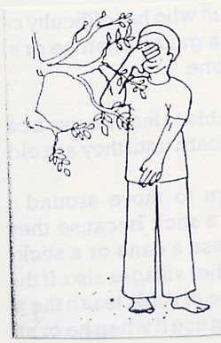 | The person may place one hand in front of the face to protect it from tree branches.  Keep talking with the person as he or she moves around in the yard. Tell him or her about the things in the yard.

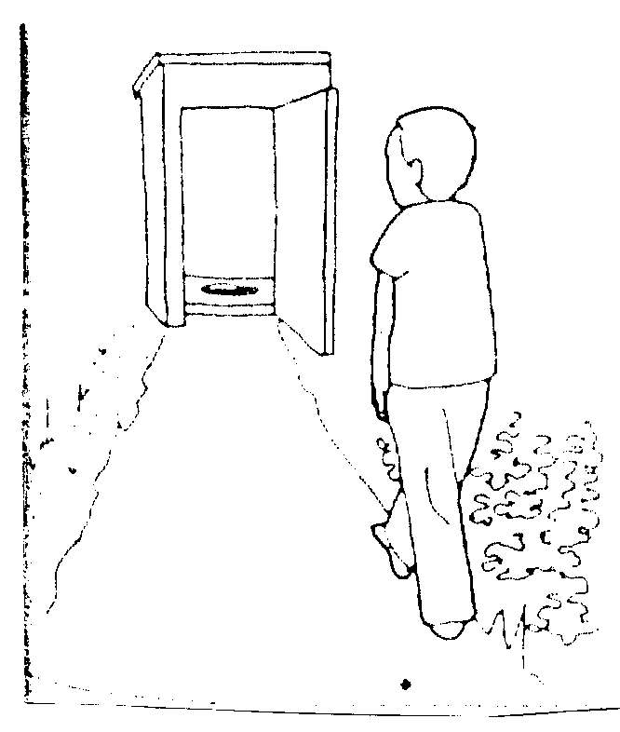 | When the person can walk alone in the yard, teach him or her to walk alone to the latrine and back.

Teach the person to use the back of one hand to follow a wall or a fence.

It is dangerous for the person to use paths that have stones, shrubs, and holes. Remove stones or shrubs that you find in the paths that the person uses. Also fill in any holes in the paths
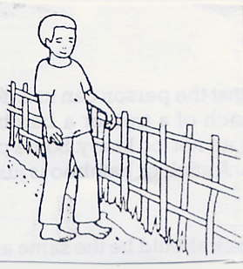

The person you train may be elderly. If so, make sure that he or she walks on safe ground in the yard so as not to fall down.

If the person has weak arms or legs they can be made stronger by doing exercises. Talk to your local supervisor about this. If exercises will help the person, your local supervisor can give you another training package with exercises to make the person’s arms and legs stronger.

How to train the person to use a long cane or a stick as a guide

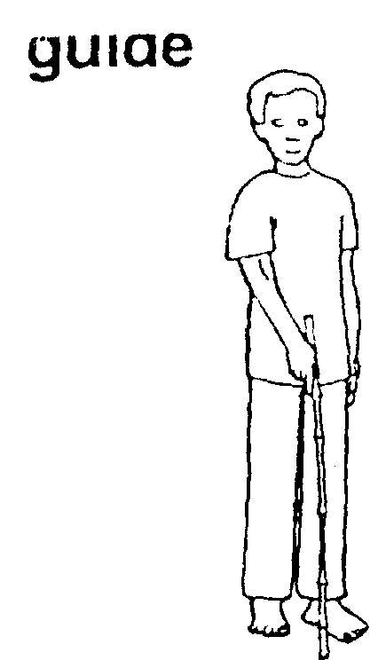 | Train a child or an adult who has difficulty seeing to use a long cane or a stick as a guide. Then he or she can move around in the village alone.  Some children may be able to learn to use a cane or stick at 6 years. Other will not learn until they are older.  Some people can learn to move around their village without a long cane or stick because they know their village. If such people use a cane or a stick they will be safer and able to go to other villages also. If the person you teach dose not use a cane or stick, teach the person to use one. Then the person can use it when he or she wants to.

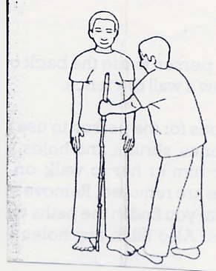 | First find a stick that the person can use. You can cut the stick from the branch of a tree or a bamboo. The stick should be straight and not too heavy. Some people want to buy a special cane. A stick or bamboo is just as good as a special cane  The length of the stick should be the same as the distance from the ground up to halfway between the person’s shoulder and waist. If the person walk quickly or takes big steps, the cane or stick can be a little longer.

.

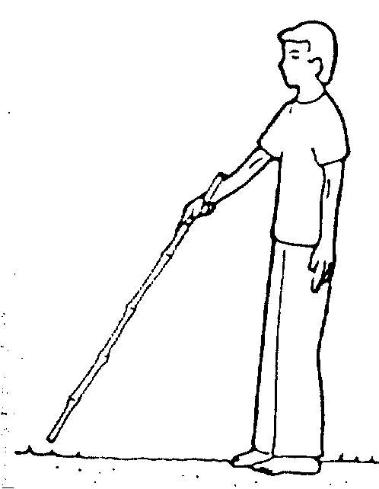 | When the person holds the stick on the ground, it should reach the ground one full step ahead of the person

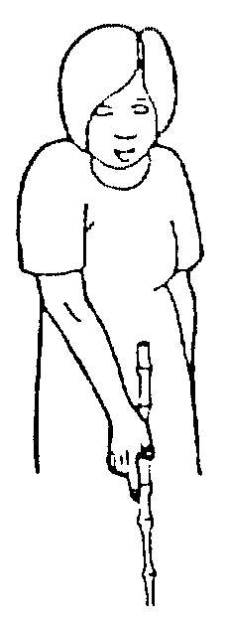 | The person holds the stick as shown in the picture.  The person’s elbow should be bent a little so that the hand is level with the center of the body.  The stick should be held just below its upper end.
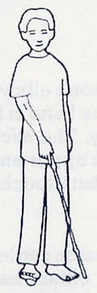 | The stick should be held so that it touches the ground lightly.

The person can learn to walk holding the stick in either hand. The person can decide which hand he or she wants to use to hold the stick.

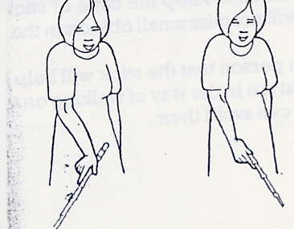 | Train the person to use movements of the wrist to move the stick from side to side while walking. The arm and hand must stay at the center of the body.

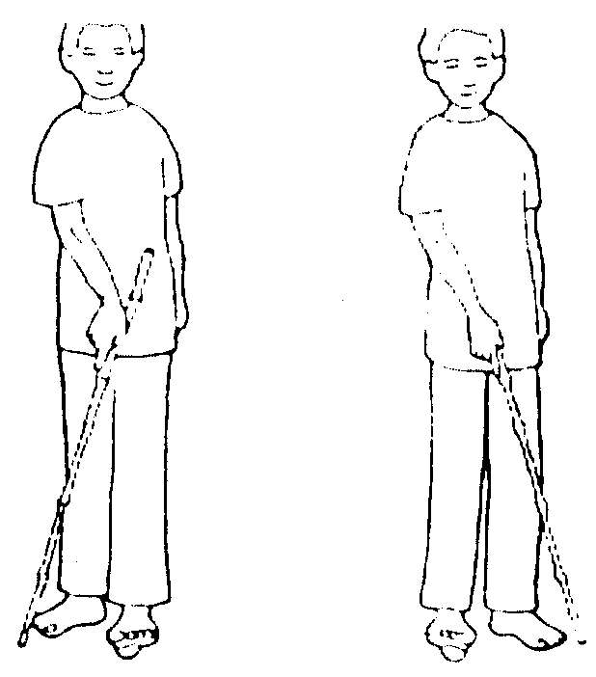 | The end of the stick should touch the ground on either side in front of the feet.  The distance between the two places where the stick touches the ground should be a little wider than the person’s shoulders.

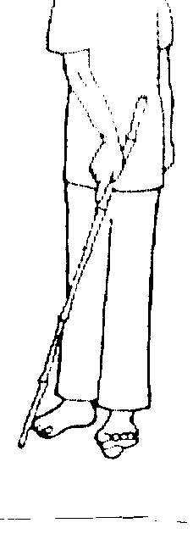 | As the stick touches the ground on side, the person should move the leg of the opposite side forward.  Then as the stick touches the ground on the other side, the person should move the other leg forward.

Train the person to keep the cane or stick close to the ground so it will not miss small objects in the path.

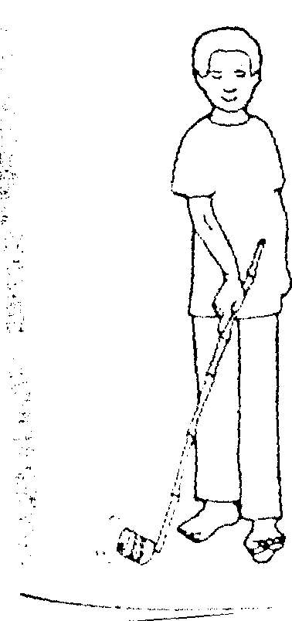 | Explain to the person that the stick will help him or her to find things that are in the way of walking on the path. That way he or she can avoid them.  As the stick touches different things, different sounds are made. Help the person to learn what things are by the sound they made.

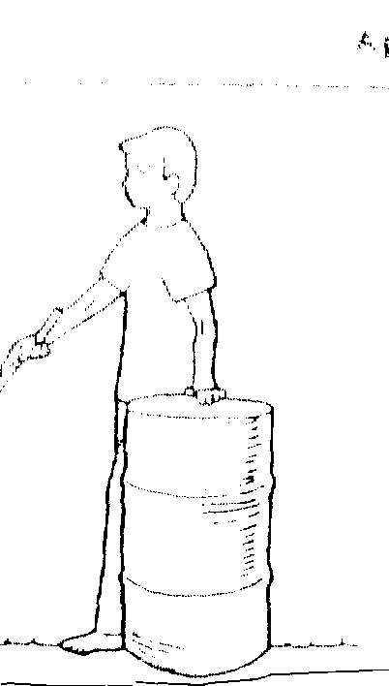 | The person can use the hand that is free to look out for taller things that are in the way.

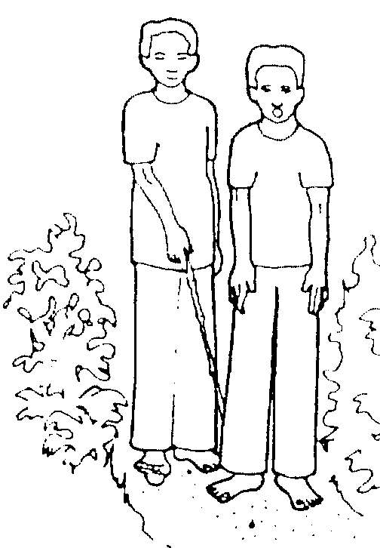 | First train the person to move the stick  When the person cannot move the stick correctly, train the person to walk using the stick.  At first walk in front of the person and talk to him or her.
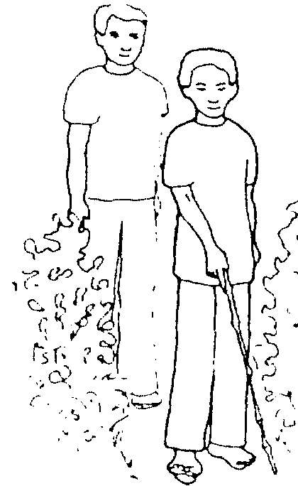 | Then walk behind the person. Let the person find his or her way with the stick. Talk to the person or stop the person only if he or she is in danger of falling or being injured.  It may take a long time to reach the person to use a stick to guide him or herself. The person may need to repeat the same activity many times in order to learn to do it correctly and safely.

If the person you train can see a little, the person should look straight ahead and use the stick to feel the ground. This will make it safer for the person to walk.

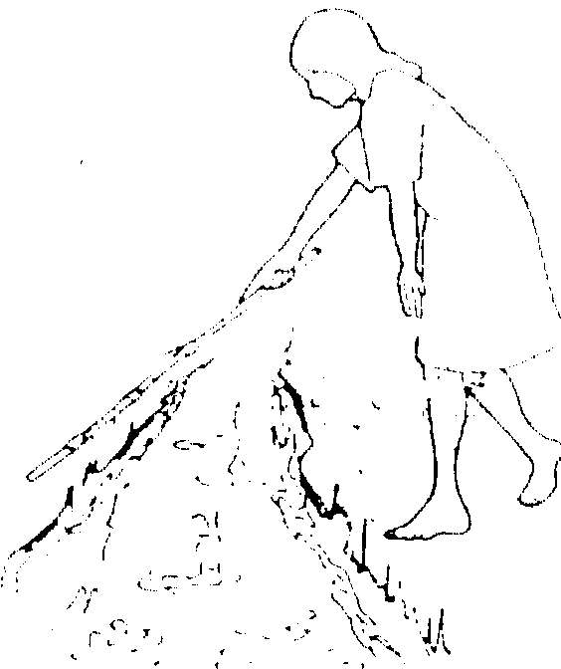 | Teach the person how to go across places such as low fences, drains streams, bridges, or rice fields.  The person may sometimes want to cross a drain or small stream. Then he or she should try to touch the opposite side with the stick to find out how wide it is. The person can also touch the bottom of the drain or stream with the stick to end out how deep it is. If the person cannot touch the opposite side of the drain or stream, he or she should ask someone for help to cross it. Or if the drain or stream in not one that the person knows, the person should ask someone for help to cross it.
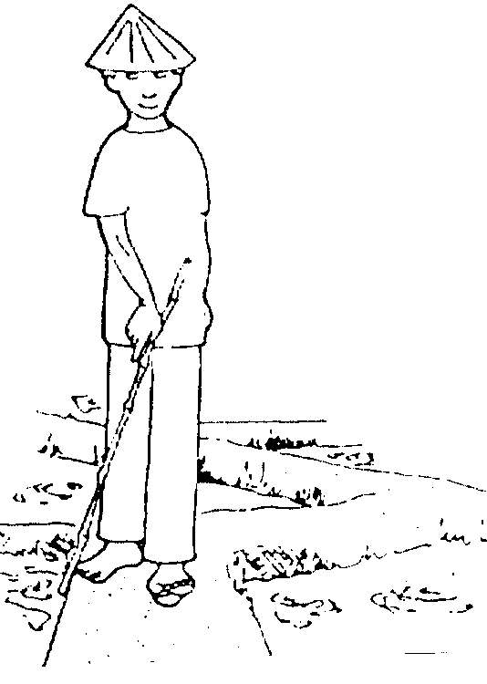 | The person may sometimes want to walk in a rice field. Then he or she should use the stick to feel both sides of the high ground between the fields. This way the person can make sure that he or she will walk on the high ground and not fall in the mud.

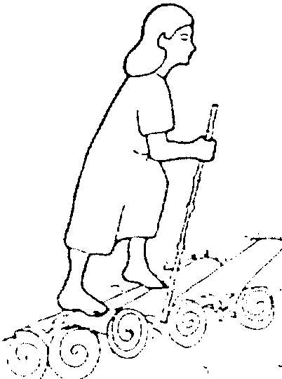 | The person may want to know how to climb steps. To learn the height of the steps, the person should feel with the stick and the feet. Teach the person to go up and down steps. The person can use a handrail for guidance (if there is one).

 | When walking by the side of a high fence the person can follow the fence with the back of the hand. The person should keep moving the stick with the other hand to look out for things in the path.
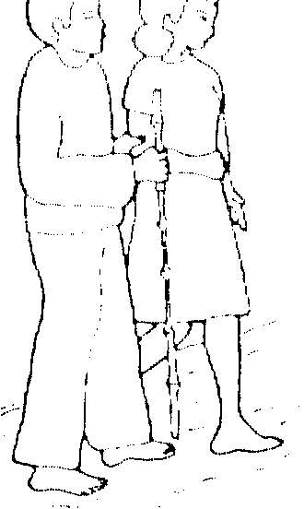 | Sometimes the person will need to walk up and down hills. If the person has difficulty doing this, he or she will need to be guided by someone else.  The person can hold the guide’s arm with one hand carry the stick in the other hand.

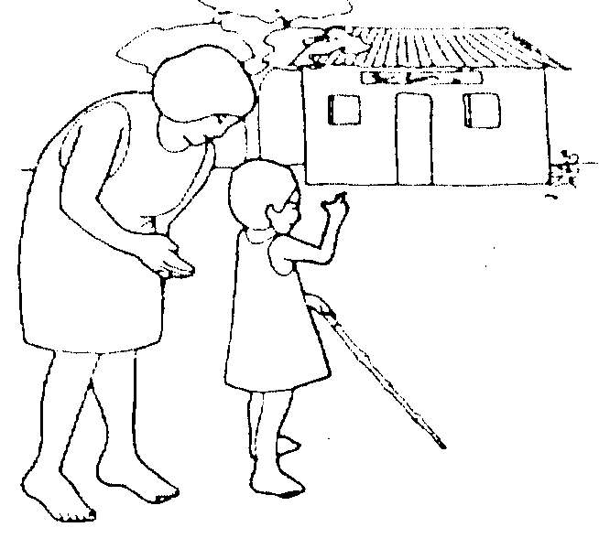 | At first go with the person to places in the village, such as the school, religious meeting places, the market, the health center, or the community center.

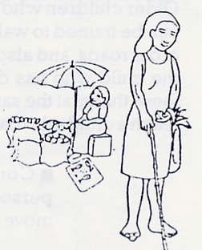 | Then let the person walk to these places without you and find his or her own way back.  Next train the person to carry objects from place to place. For example, to fetch water or to carry things from the market.  When the person learns to do a new activity or does something well, tell him or her how well he or she is doing. It will make the person happy and will encourage him or her to want to learn more.

How to teach the person to move safely on roads and to travel by bus
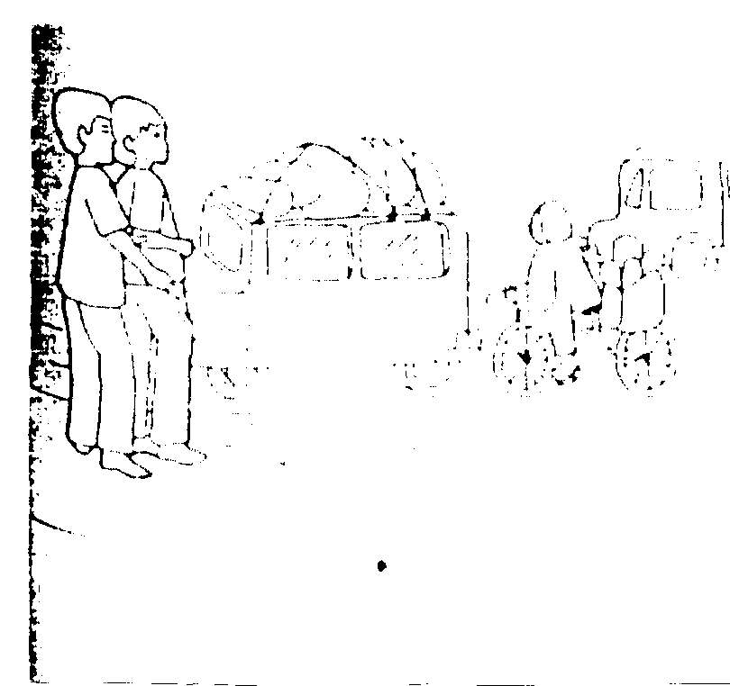 | Teach the person to walk on the side of the road facing the traffic which id coming toward him or her.  On small roads, teach the person to listen for the sounds of cars and buses coming from both sides. Explain to the person that he or she must cross the road only when the road is clear or the traffic has stopped.  If the person cannot tell when there is traffic on the road, tell him or her to ask someone for help to cross the road.

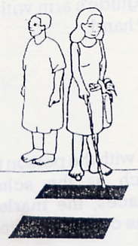 | At busy roads, the person should always ask someone to guide him or her across the road. Tell the person to hold the guide’s arm just above the elbow.  If there are signs to show where people should cross the road, train the person to cross the road at these places.  If the person travels by bus, he or she can ask for help from the driver or other passengers. They can tell him or her where to get off the bus.

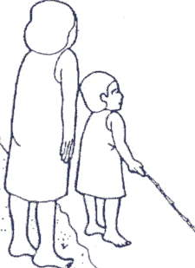 | Teach a very young child not to go near traffic.  Older children who have difficulty seeing can be trained to walk along busy roads, to cross roads, and also to travel by bus. Train the child who has difficulty seeing to do these things at the same age that you would teach a child who can see.

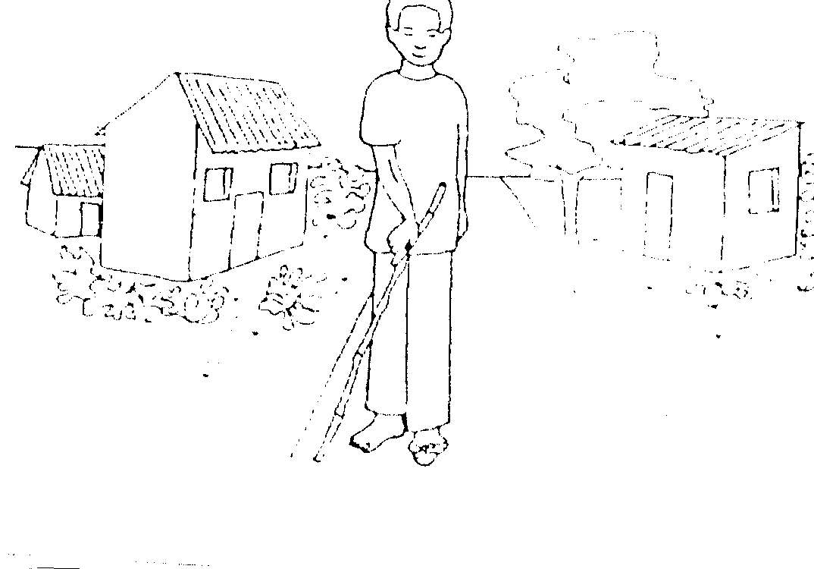 | Continue training the person until he or she can move around safely.  An adult who has difficulty seeing can learn to go to work alone. A child can learn to go to school alone. An adult or a child may want to go alone to the market, to the well for water, or to visit friends and neighbors in the village.  Continue training the person until he or she can do all these things safely.

Using money

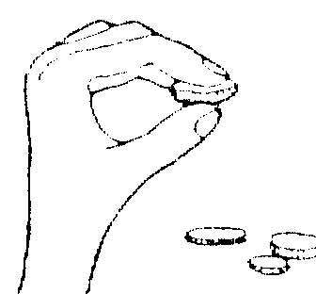  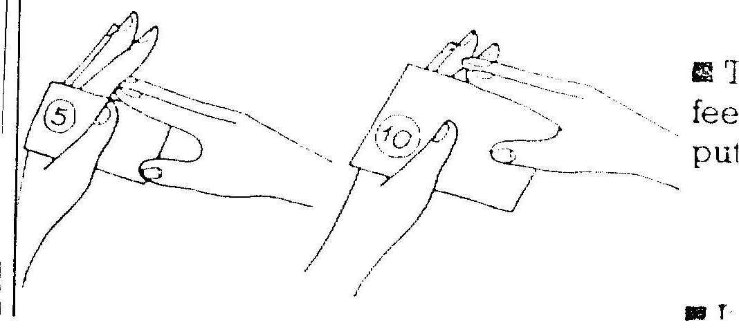  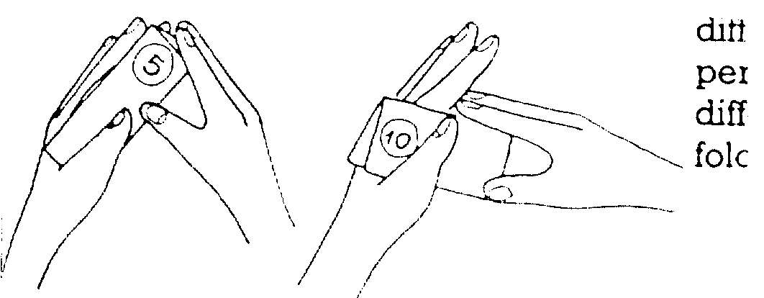 | Teach the person to know different coins by feeling their size, shade, and weight.  Teach the person to know notes by feeling their size. The person can do this by putting the notes between the fingers.  If notes are the same size, fold notes of different values in different ways. Teach the person how you have folded the notes of different values by feeling the way they are folded.

About the person’s home

The person you train needs to live in a safe home. The person should be able to walk around the home safely.

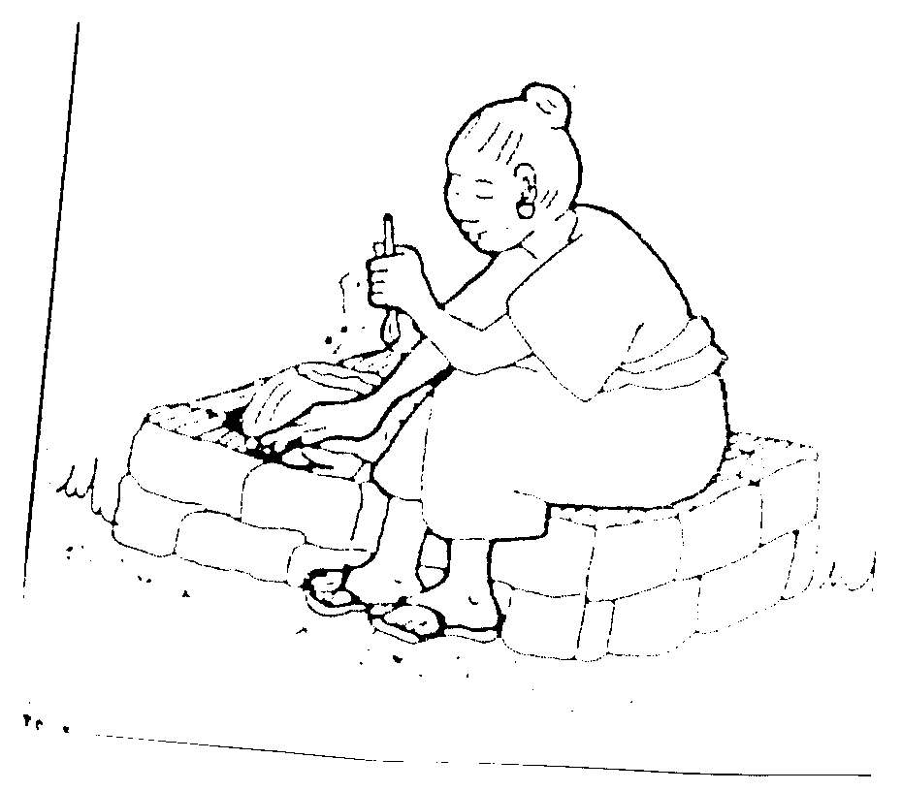 | The stove, oven, or fire for cooking must be well protected so that the person cannot burn himself or herself

If there is a well, it must be protected or covered so that the person cannot fall into it.

If the paths around the home have large stones, which makes it difficult for the person to walk, remove the stones. It there are holes in the paths, fill the holes in with sand or earth.

The person’s home may need improvement. For example, the roof may be letting in water; or the kitchen might need’ shelves. If there is no one in the family who can help speak to your community leaders and ask for their help.

